Liberty University

CSIS 331

Lab 5 Instructions

**Packet Tracer:**

*[Adapted from Cisco Networking Academy Intro to Networking 7.4.1.2]*

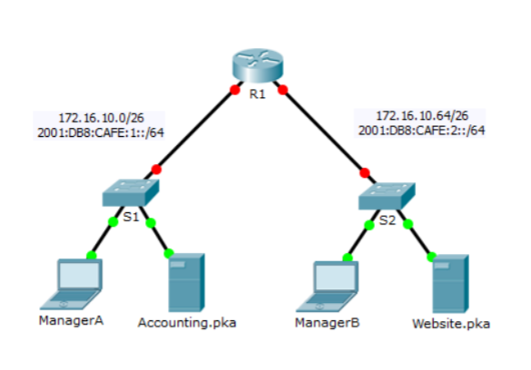

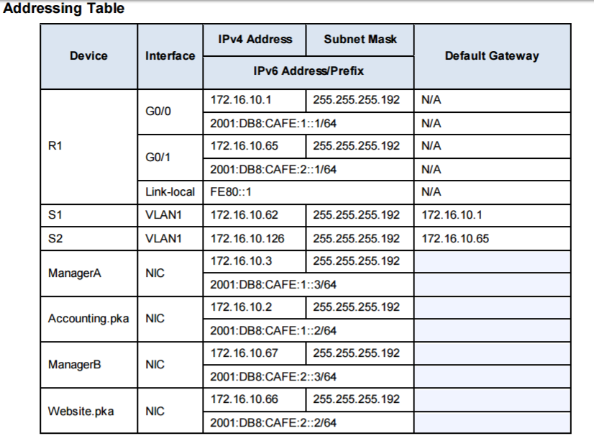

Overview

Your company has won a contract to set up a small network for a restaurant owner. There are two restaurants near each other, and they all share one connection. The equipment and cabling is installed and the network administrator has designed the implementation plan. Your job is to implement the rest of the addressing scheme according to the abbreviated Addressing Table and verify connectivity.

Configuration Requirements

• Complete the Addressing Table documentation on the Lab 5 Answer Sheet.

• Configure R1 with IPv4 and IPv6 addressing.

• Configure S1 with IPv4 addressing. S2 is already configured.

• Configure ManagerA with IPv4 and IPv6 addressing. The rest of the clients are already configured.

• Verify connectivity. All clients should be able to ping each other and access the websites on .Accounting.pka and Website.pka. List the Ping Output on your Lab 5 Answer Sheet.